*MSSE SOFTWARE, INC.*

**System Test (DVT & SVT) Plan for GolfScore**

**Deem Alqudaimi**

**Oct 8th, 2023**

Confidential and Proprietary Information of MSSE Soft Worldwide

Contents

1.0 Introduction 3

1.1. Objective 3

1.2. Project Description 3

1.3. Process Tailoring 3

1.4. Referenced Documents 3

2.0 Assumptions/Dependencies 3

3.0 Test Requirements 3

4.0 Test Tools 4

5.0 Resource Requirements 4

6.0 Test Schedule 4

7.0 Risks/Mitigation 4

8.0 Metrics 4

Appendix A – Detailed Resource Requirements 5

Appendix B – Detailed Test Schedule 6

# Introduction

## Objective

The Test Plan is an aggregation of information, which describes the entire test activity for this project. It covers the entire testing effort (unit, development test, system verification test, and Beta). It identifies the product requirements, schedules, resource requirements (people, effort and equipment), quality, assumptions, exclusions, and risks.

A preliminary Test Plan is prepared for the Project Team during the System Phase of PEAQ Process. This Test Plan will be updated in the earliest possible time of the Implementation Phase, so that progress can be tracked during implementation.

## Project Description

GolfScore is a program used to generate golf tournament results for golfers along each course. This program takes an input text file (as described in the SRS) and produces three output text files (also described in the SRS).

## Process Tailoring

This project will use software development and management processes as a guideline. Some tailoring of The GolfScore program requires no external dependencies. Thus, the test plan is tailored along Functional and Non-functional Testing in the framework of Design Verification and System Validation. Testing is carried out under the following phases: • Entrance Test: To verify that the program can correctly be executed, and handle input parameter errors as specified in the SRS. See Appendix C for a description of the Entrance Testing test cases, and Appendix A for the SRS. • Main Test: To verify the correctness of program execution. To check if the program accurately processes the input data as specified and produces the required outputs. Further, the program’s handling of input data errors and output errors is checked for correctness. See Appendix C for a description of the Main Testing test cases. • Exit Test: To verify if the program produced the required outputs and saved them in the correct format and in the correct location. See Appendix C for Exit Testing test cases. • Regression Test: After defects must have been identified during testing and processed, all tests are run again to ensure proper behaviour. The following references were used in creating this document: a. Software Requirements Specification for GolfScore, Revision 1, July 18, 2017. b. System Verification Test Plan for Advanced Color Module, Revision 2, 22 February 2000. Assumptions/Dependencies

[All assumptions for carrying out this test effort successfully are listed here. Some requirements assumptions might be necessary to scope the test activities. Also, assumption of responsibility to conduct unit, integration, SVT, regression, and beta tests.

Also listed here are the external dependencies, such as code completion by a certain date to meet the test schedule. Other dependencies might include prototype available and functional by a certain date.]

# Assumptions/Dependencies

It is assumed that the development team unit test their code while developing the software, and also perform integration testing. Customer validation testing is assumed to be carried out by field personnel together with the customers. For conformation with the set schedule, the program must be made available by the development team by January 4, 2021.

# Test Requirements

Entrance Tests:

♠ The program is written in either C or C++.

♠ The program runs on a PC running Windows 2000 or any later version.

♠ The program will run as a stand-alone executable.

♠ The program can be run from the command line prompt.

♠ The program is run with valid input parameters.

Main Tests:

♠ The number of golf courses specified for the tournament must be from 1 to 5.

♠ Each golfer is expected to play each course once.

♠ The number of golfers entered in the tournament can be from 2 to 12.

♠ Par for holes on each course must be either 3, 4, or 5.

♠ Score earned by a golfer for each hole played is between 0 and 6 (0 and 6 included).

♠ The first set of records in the input file (course records) exist and follow the specified format for each entry.

♠ There is a delimiter record that signals the end of course records.

♠ A second set of records (golfer records) exist in the input file and each entry follows the specified format.

♠ There is a delimiter record that signals the end of the input file.

Exit Tests:

♠ The program should produce a few reports corresponding to the specified options.

♠ The generated reports should be saved as text files in the specified output directory (or if not specified, in the directory of the input file) with the extension “. rep”.

♠ If requested, the tournament ranking report should contain a list of all golfers in the specified format. The list should be in descending order of final score and should be saved with an output filename of trank.rep.

♠ If requested, the golfer report should contain a list of all golfers in the specified format. The list should be alphabetical with respect to the golfers’ last name and should be saved with an output filename of golfer.rep.

♠ If requested, the course report should contain a section for each Golf Course listed in the input Course Records in the specified format. It should be saved with

# Test Tools

To aid the testing process, the following testing tools are required:

• Defect reporting and tracking software

• Installation media for multiple Windows versions above 2000 (e.g. XP, Vista, 7, 8, 8.1, & 10)

# Resource Requirements

The following resource would be required:

• GolfScore Program version 1.1

• Three PCs capable of hosting virtual machines

• A virtualization software

• Three Test Group personnel with at least 70% of his/her time available for this effort.

See Appendix A for details.

# Test Schedule

|  |  |  |  |
| --- | --- | --- | --- |
| NO. | Test | Start | Finish |
| 1 | Test Development | 22.12.2020 | 04.01.2021 |
| 2 | Program Availability | 04.01.2021 | NA |
| 3 | Enhance Testing | 05.01.2021 | 11.01.2021 |
| 4 | Main Testing | 12.01.2021 | 24.01.2021 |
| 5 | Exit Testing | 24.01.2021 | 30.01.2021 |
| 6 | Regression Testing | 31.01.2021 | 05.02.2021 |

# Risks/Mitigation

Without having a program that enforces compliance in the structure of input data, there’s a high probability of input data errors.

# Metrics

The following metrics data will be collected. Some will be collected prior to, and some after product shipment.

Prior to shipment:

Effort expended during DVT, SVT and Regression

# of defects uncovered during DVT, SVT and Regression, and development phase each defect is attributable to

Test tracking S-Curve

PTR S-Curve

After shipment:

# of defects uncovered and development phase each defect is attributable to

Size of software

Appendix A – Detailed Resource Requirements

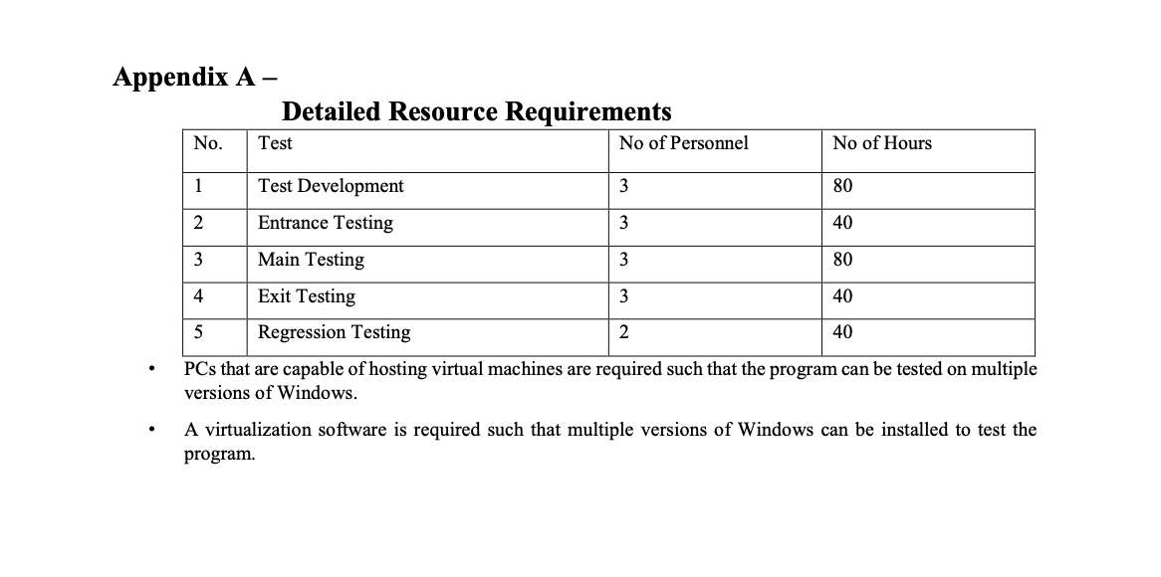

[To estimate the resource, all test activities must be identified and resources needed to accomplish the activities estimated. Detailed estimates will be shown here. This consists of identifying all project test activities by the Test Group and the number of hours estimated to accomplish these activities. Be specific. Show specific responsible test engineer’s names, if possible. A grand total of the effort must be shown here, as well as in Section 5.0.]

Appendix B – Detailed Test Schedule

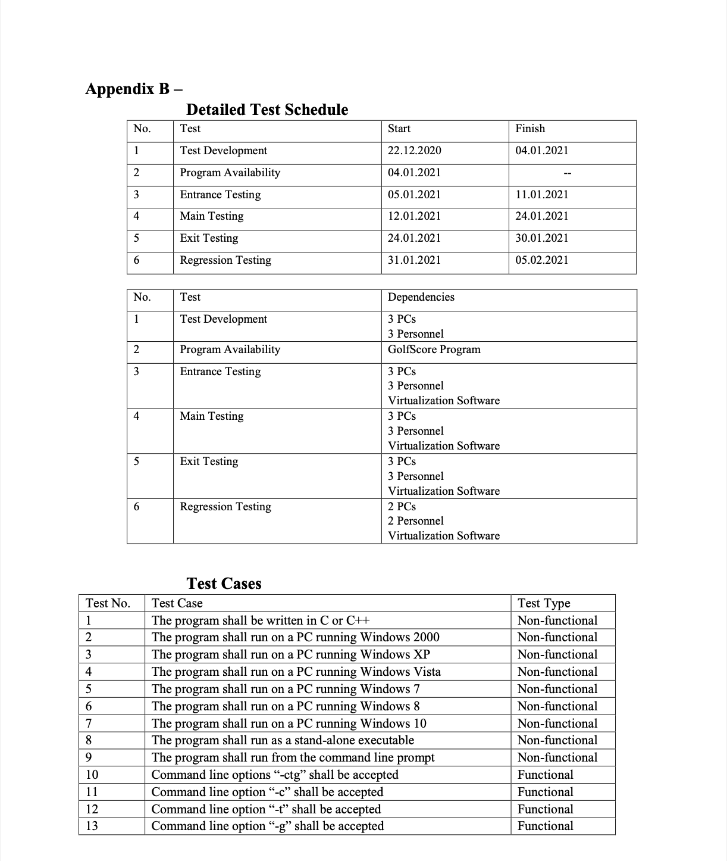

[Attach two charts, viz. Gantt and PERT. In Gantt, main activities are shown as a list on the Y-column with bars parallel to the X-axis, showing the timeframe to perform activities. In PERT, dependencies of each activity must be identified.]

